Duan Nguyen

CSCI 406

3rd April 2024

Timber Problem – Analysis – Part 1

In this problem’s recursive call, the function $T(i, j)$ is called twice with $T(i+1, j)$ and $T(I, j-1)$, and then each of them would call the function twice again. Therefore, at each level of the recursive tree, the number of nodes double every depth, so in theory, the average complexity of $T(i, j)$ would be .

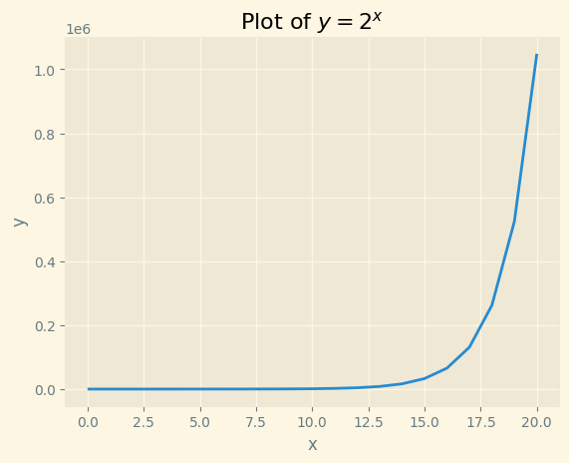 To test so, here are two graphs in range of 0 to 21, one is graph of $y\left(x\right)= 2^{x}$, and the other is the recorded time performance of $T(i, j):$

In both graphs, the observed data have very similar trends with $y\left(x\right)= 2^{x}$ but at different scales. Additionally, I have 3 datapoints highlighted along with their **n** value and time it took $T(i, j)$ to perform, and as **n** increase by 1, the time performance is approximated to be doubled. Therefore, the asymptotic complexity of $T(i, j)$ is $Ѳ\left(2^{n}\right).$